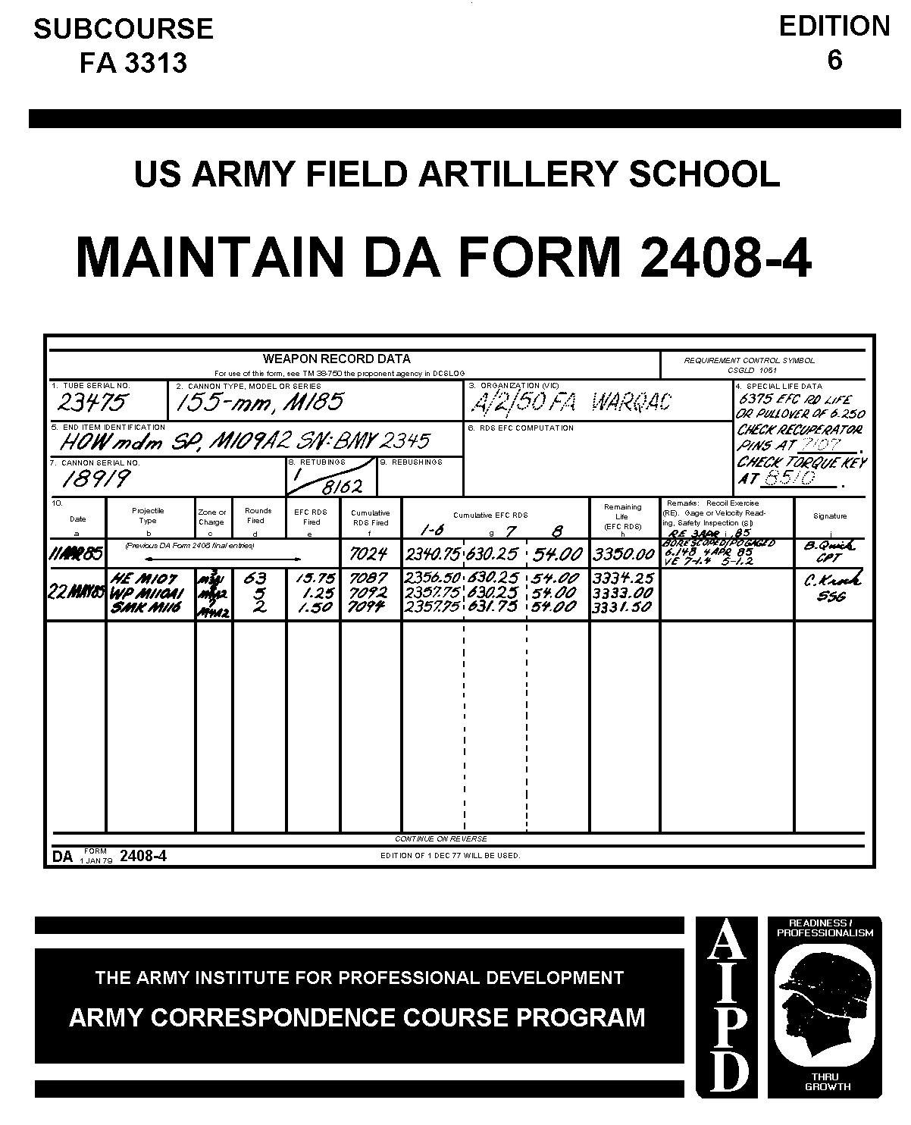

HOWITZER CREW MEMBER
MOS 13B, SKILL LEVEL 1 THROUGH 4

MAINTAIN DA FORM 2408-4

SUBCOURSE 3313

US Army Field Artillery School
Fort Sill, Oklahoma

Three Credit hours

GENERAL

This subcourse is designed to train the skills necessary for performing tasks related to maintaining the DA Form 2408-4, Weapon Record Data. This subcourse is presented in one lesson corresponding to a terminal objective supporting the following soldier's manual task:

TASK NO: 061-266-3323.

TASK: Maintain DA Form 2408-4 (Weapon Record Data).

CONDITIONS: You will be given a DA Form 2408-4 and a record of rounds fired by type and charge.

STANDARDS: Make all required entries on DA Form 2408-4 IAW DA Pam 738-750.

W7882

TABLE OF CONTENTS

Section Page

TITLE PAGE i

TABLE OF CONTENTS ii

ADMINISTRATIVE INSTRUCTIONS iii

GRADING AND CERTIFICATION INSTRUCTIONS iii

Lesson: Maintain DA Form 2408-4

Introduction 1

Terms and Definitions 1

Use of DA Form 2408-4 2

Form Entries 4

Entries from Previous DA Form 2408-4 12

Disposition of DA Form 2408-4 22

Self-Evaluation 23

Summary 25

EXAMINATION E-1

ADMINISTRATIVE INSTRUCTIONS

Subcourse content. This subcourse consists of one lesson. An introduction presents an overall view of the subject. The lesson then explains how to perform each task as it pertains to maintaining the DA-Form 2408-4, Weapon Record Data.

Supplementary requirements. The following subcourses should be completed before taking this subcourse: None.

Materials needed. You will need a Number 2 pencil, ballpoint pen, and paper (to be furnished by student) to complete this subcourse.

Supervisory assistance. There are no supervisory requirements for completion of this subcourse.

References. No supplementary references are needed for this subcourse.

GRADING AND CERTIFICATION INSTRUCTIONS

Instruction to the student. This subcourse has an examination that is a performance-based, multiple-choice test covering one lesson. You must score a minimum of 75 percent on this test to meet the objective of the subcourse.

Credit hours. Three credit hours will be awarded for successful completion of the subcourse.

* * * IMPORTANT NOTICE * * *
THE PASSING SCORE FOR ALL ACCP MATERIAL IS NOW 70%.
PLEASE DISREGARD ALL REFERENCES TO THE 75% REQUIREMENT.

MAINTAIN DA FORM 2408-4

OBJECTIVE

Upon completion of this lesson, you will be able to maintain DA Form 2408-4, Weapon Record Data, by making correct entries when initiating, firing, and disposing of the form.

REFERENCES

This lesson is based on DA Pam 738-750 and other materials approved for US Army field artillery instruction; however, development and progress render the text continually subject to change. Therefore, base your examination answers on material presented in this text rather than on individual or unit experience with which you may be familiar.

1. INTRODUCTION. DA Form 2408-4, Weapon Record Data, is a historical document that is a permanent record of information pertaining to the receipt, operation, maintenance, modification, transfer, or disposal of equipment. DA Form 2408-4 provides a continuous record of firings and other information related to the length of time a tube can be used before it needs to be replaced. Therefore, data on the form are used to determine whether a howitzer may be fired without the possibility of the tube exploding because of bore wear or fatigue. This form is also used to record certain firing information pertaining to the cannon. DA Form 2408-4 will accompany the howitzer when it is to be fired, repaired, evacuated to support maintenance, transferred, or placed in storage.

2. TERMS AND DEFINITIONS. To help you understand how to maintain DA Form 2408-4, become familiar with the following list of definitions. These definitions will help you understand the text and maintain the form.

a. Howitzer. A weapon system that delivers a round of ammunition with medium velocity, by low or high trajectories, to a designated target.

b. Muzzle velocity. The speed, measured in meters per second, that a projectile travels after it leaves the muzzle of a weapon.

c. Cannon. That part of a howitzer that consists of the breech assembly and the tube.

d. Tube. That part of the cannon that is screwed into the breech assembly.

e. Breech assembly. That part of the cannon that contains the breech-block, which acts as a gas tight seal, located at the rear of the cannon.

f. Serial number (SN). A specific identification number assigned to an individual item of material.

g. Type. A particular group of items having the same characteristics (for example, howitzers, trucks, and aircraft).

h. Model. A means of equipment identification that is usually preceded by the letter M (for example, M109A2, M101A1, and M102).

i. Series. A group of similar items (for example, M109-series howitzers consists of M109, M109A1, M109A2, and M109A3).

j. Unit identification code (UIC). A code used for encoding identification of military units. The UIC consists of six characters (for example, WP4QAC and WA2NSS).

k. Equivalent full charge (EFC). A factor used for determining the life of a howitzer tube.

l. End item. A final combination of parts and/or materials, which is ready for its intended use (for example, ship, tank, howitzer, and truck).

m. Special life data. The total EFC life designated for a specific type of tube before it is replaced.

n. Pullover gage. A device used to measure the interior portion of a tube for wear.

o. Retubing. Replacing a tube that has been condemned because of EFC life factor or pullover gage measurement.

p. Rebushing. Replacing a bushing that has reached its tube life expectancy.

q. Borescope. A method of inspecting the interior components of a tube for cracks or deterioration.

r. Cumulative. Adding new items of the same type to a previous total to obtain a new total.

s. Propelling charge. A powder charge that is set off in a howitzer to propel a projectile from the muzzle of the howitzer.

t. Zone. An area in which projectiles will fall when a given propelling charge is used and the elevation is varied.

3. USE OF DA FORM 2408-4. DA Form 2408-4 is used to record the identification of a particular piece of equipment, to keep a record of the number of rounds fired, and to record special information; such as EFC factors, EFC tube life remaining, muzzle velocity, borescope data, and pullover (PO) gage data. Now that you have studied the terms, look at the blank DA Form 2408-4 shown in Figure 1.

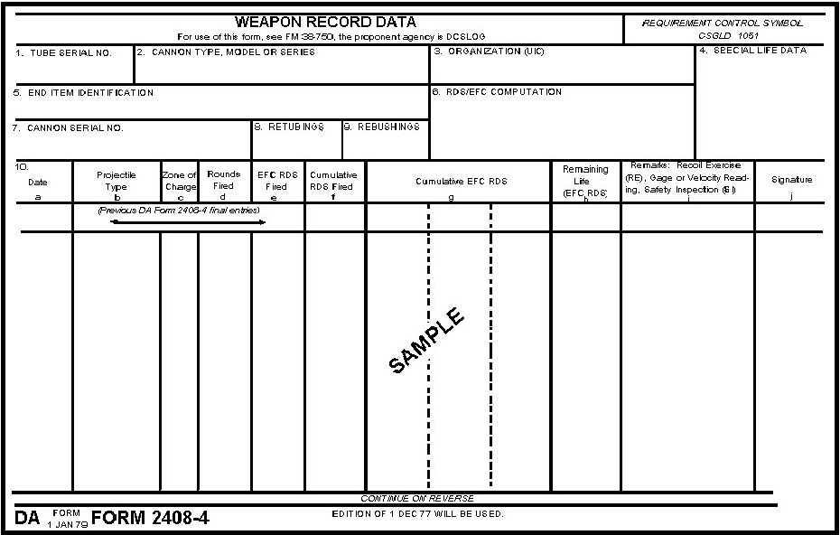

Figure 1. DA Form 2408-4.

Now look at the form when it has been completed (Fig 2).

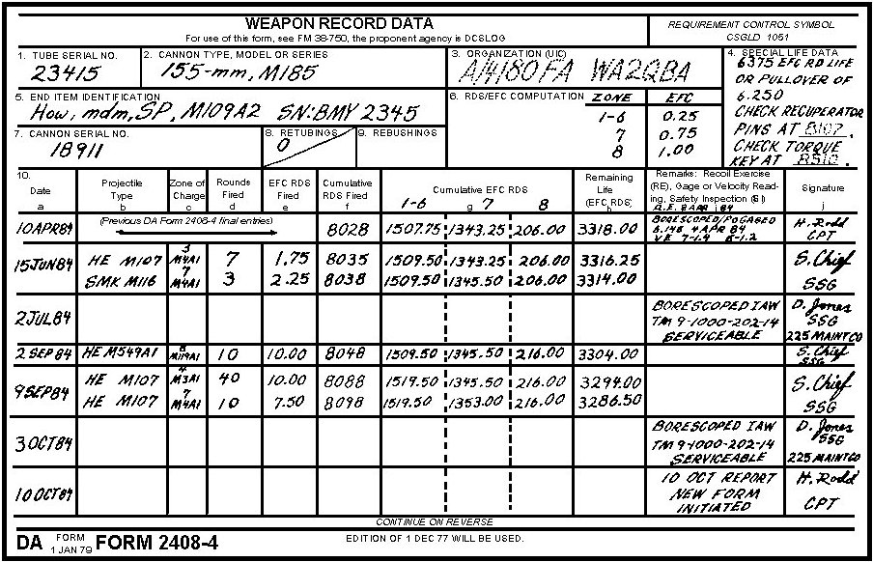

Figure 2. DA Form 2408-4 with data filled in for M109A2.

4. FORM ENTRIES. DA Form 2408-4 is divided into 10 blocks. Block 10 is divided into 10 columns (a through j). The section chief, chief of firing battery, executive officer, battery commander, and support maintenance personnel are authorized to make entries on and sign the form. All entries will be made in black, blue-black, or blue ink except for block 3, which will be a pencil entry. This entry is made in pencil in case the howitzer is transferred from one unit to another or the unit is redesignated. Since the old information can be erased and the new information inserted, a new form will not have to be initiated.

a. Block 1. Enter the cannon tube serial number. You will find the tube serial number stamped on the muzzle (front) end of the tube except for the M101A1 and M102.

b. Block 2. Enter the cannon type (105-mm, 155-mm, or 203-mm [8 inch]) and tube model number (M2A2, M137A1, M1A2, M199, M185, or M201). This information is found on the breech ring of the howitzer.

c. Block 3. Enter your unit designation and UIC in pencil. This data can be obtained from the chief of firing battery or executive officer.

PRACTICE EXERCISE:

Complete the following exercises by circling T for True F for False, circling the letter preceding the correct answer, or filling in the blanks, as appropriate. Be sure to complete the practice exercises as they appear. They are "building blocks" and will help you complete the rest of the subcourse successfully. The answers follow the last exercise and are separated by rows of slashes (////). If any of your answers are incorrect, restudy the appropriate part of the subcourse before you continue.

1. Fill in blocks 1 through 3 in Figure 3. Use the following data:

- Btry A, 2d Bn, 34th FA; WB3AQA.
- 22863 (tube serial number).
- 155-mm, M185.

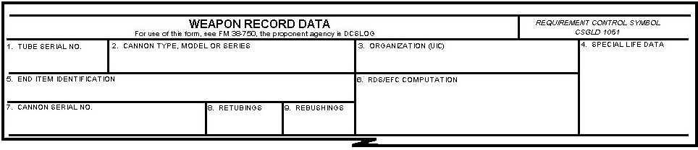

Figure 3. Blocks 1 through 9 of DA Form 2408-4.

/////////////////////////////////////////////////////////////////////////////////////////////////////////////////////////////////////////////////////////////////

ANSWER:

1.

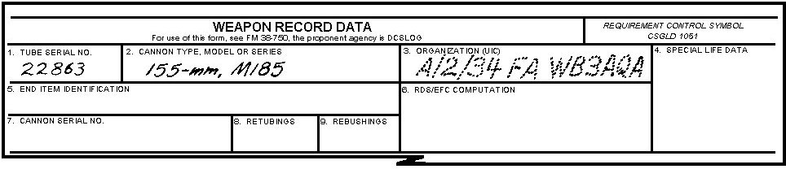

Figure 4. Blocks 1 through 3 completed.

/////////////////////////////////////////////////////////////////////////////////////////////////////////////////////////////////////////////////////////////////

d. Block 4. Enter the special life data for your type of howitzer tube. A list of special life data by model of howitzer and tube type follows. Become familiar with this information.

Model of Howitzer Tube Type Special Life Data

M101A1 M2A1, 105-mm 5,000 EFC round life
M2A2, 105-mm 7,500 EFC round life

M102 M137A1, 105-mm 6,375 EFC round life

M114A1/A2 M1A1/A2, 155-mm 7,500 EFC round life

M198 M199, 155-mm 1,750 EFC round life

M109A1/A2/A3 M185, 155-mm 6,375 EFC round life

M110A2 M201A1, 203-mm 7,500 EFC round life (8 inch)

NOTE: Block 4 will also contain information on any maintenance to be pulled on a rounds-fired basis.

e. Block 5. Enter weapon end item identification, model of howitzer, and howitzer serial number. The end item identifications and locations of howitzer serial numbers are listed below.

NOTE: A listing of abbreviations approved for use on all DA forms can be found in Appendix B of DA Pam 738-750 under the column heading of NOUN ABBR.

End Item Identification Serial Number
and Model Location

Howitzer (how), light, towed, M101A1 Left elevating arc

Howitzer, light, towed, M102 Right side of upper carriage

Howitzer, medium (mdm), towed, M114A1/A2 Right trunnion mount

Howitzer, mdm, towed, M198 Right trunnion mount

Howitzer, mdm, self-propelled (SP), Driver's compartment
M109A1/A2/A3 (left side)

Howitzer, heavy (hvy), SP, M110A2 Driver's compartment
(left side)

f. Block 6. Enter EFC factors for the various zones for your howitzer. Enter the zone figures above the subcolumns in column 10g. Below is a list of howitzers and their EFC factors by zone.

Howitzer EFC Factor

M101A1 Zones: 1-6 0.25 EFC
7 1.00 EFC

M102 Zones: 1-6 0.10 EFC
7 1.00 EFC

M114A1/A2 Zones: 1-6 0.25 EFC
7 1.00 EFC

M198 Zones: 3-6 0.05 EFC
7 0.10 EFC

8 0.33 EFC

8S 1.00 EFC

M109A1/A2/A3 Zones: 1-6 0.25 EFC
7 0.75 EFC
8 1.00 EFC

M110A2 Zones: 1-6 0.25 EFC
7-8 0.7 EFC
9 1.00 EFC

PRACTICE EXERCISE:

2. Fill in blocks 1 through 6 in Figure 5. Use the following data:

- Btry B, 8th Bn, 6th FA; WD2ASB.
- 23986 ( tube ).
- Howitzer, mdm, SP, M109A2.
- SN: BMY 1345.
- 155-mm, M185.
- Zone 1 through 6: 0.25 EFC.
- Zone 7: 0.75 EFC.
- Zone 8: 1.00 EFC.
- 6.375 EFC round life or pullover of 6.250.
- Check recuperator pins at _____________ .
- Check torque key at _____________ .

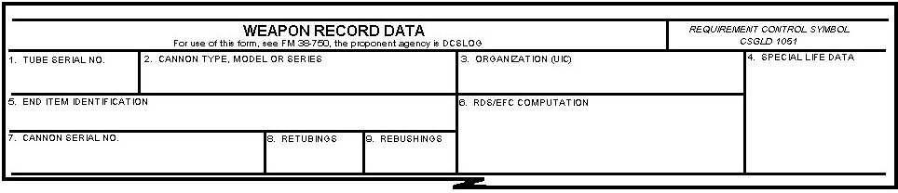

Figure 5. Blocks 1 through 9 of DA Form 2408-4.

////////////////////////////////////////////////////////////////////////////////////////////////////////////////////////////////////////////////////////////////

ANSWER:

2.

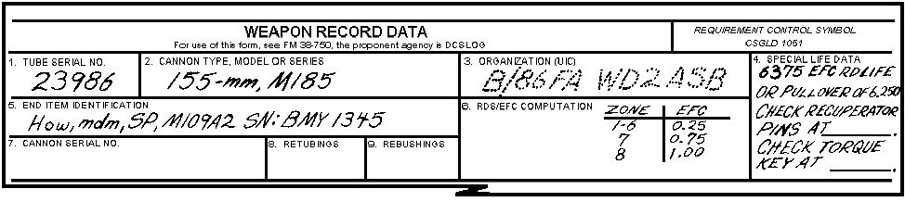

Figure 6. Blocks 1 through 6 completed.

////////////////////////////////////////////////////////////////////////////////////////////////////////////////////////////////////////////////////////////////

g. Block 7. Enter the cannon serial number. The serial number is stamped on the breech ring of all howitzers. Following is a list of serial number locations by howitzer model number.

Howitzer Model Number Location

M101A1 Breech ring top—left side

M102 Breech ring top—top center

M114A1/A2 Breech end—center

M198 Breech end—left

M109A1/A2/3 Breech end—right

M110A2 Breech end—left

h. Block 8. Enter the number of times that the installed breech ring has been retubed. If the breech ring has not been retubed, enter zero. Each time a breech ring is retubed, the cumulative times that it has been retubed is stamped on the breech ring. Below is a list of stamping locations by howitzer model number.

Model Number Location

M101A1 Breech end—top left

M102 Breech end—right center

M114A1/A2 Not retubable

M198 Breech end—bottom right

M109A1/A2/3 Breech end—bottom left

M110A2 Breech end—bottom right

h. Block 8. Divide this block into 2 sections by drawing a diagonal (slanted) line from the upper right to the lower left corner.

(1) In the first section, center the number of times the installed breech ring has been retubed. If the breech ring has not been retubed, enter zero. Each time a breech ring is retubed, the cumulative times that it has been retubed is stamped on the breech ring. Below is a list of stamping locations by howitzer model number.

Model Number Location

M101A1 Breech end—top left

M102 Breech end—right center

M114A1/A2 Not retubable

M198 Breech end—bottom right

M109A1/A2/A3 Breech end—bottom left

M110A2 Breech end—bottom right.

(2) In the second section, put the total cumulative EFC rounds fired on the end item at the time of the last retubing. This figure is the total rounds on the whole system (the chassis or carriage) for overhaul.

i. Block 9. Enter the number of times that the installed breech ring has been rebushed. This space will remain blank except for the M110A2 SP howitzer, which is the only howitzer with a breech ring that can be rebushed. Rebushing information is stamped on the breech end, bottom right.

PRACTICE EXERCISE:

3. Fill in blocks 1 through 9. Use the following data:

- Tube SN: 26895
- 203-mm, M201A1
- Rebushing 1.
- Retubed 2/10, 528.
- How, hvy, SP, M110A2 (SN: BMY 143).
- Btry A, 3d Bn 14th FA; WA2NAA.
- Zones 1 through 2: 0.25 EFC.
- Zones 7 through 8: 0.70 EFC.
- Zone 9: 1.00 EFC
- 7,500 EFC round life.
- Cannon SN: 1389.

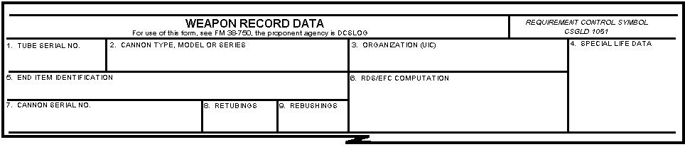

Figure 7. Blocks 1 through 9 of DA Form 2408-4.

////////////////////////////////////////////////////////////////////////////////////////////////////////////////////////////////////////////////////////////////

ANSWER:

3.

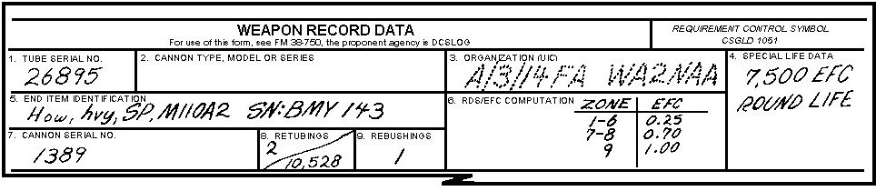

Figure 8. Blocks 1 through 9 completed.

/////////////////////////////////////////////////////////////////////////////////////////////////////////////////////////////////////////////////////////////////

j. Block 10. This block is divided into 10 columns lettered a through j. Look at block 10 in the DA Form 2408-4 (Fig 9). Column g has dotted lines in it. These dotted lines further subdivide this column and will be explained later.

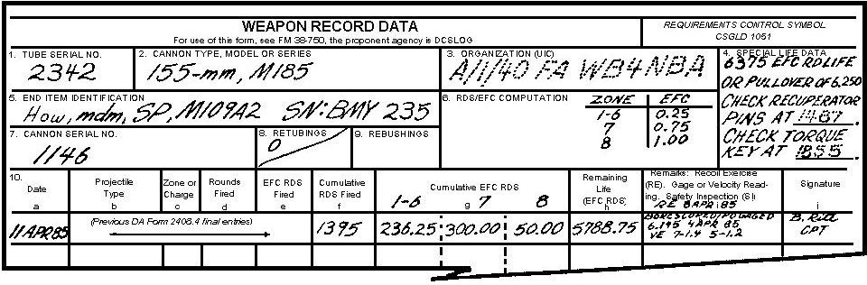

Figure 9. Blocks 1 through 10 of
DA Form 2408-4.

5. ENTRIES FROM PREVIOUS DA FORM 2408-4. Make sure totals from the previous form are entered correctly on the new form when transferring data. A new form is initiated when the old form is completely filled out (front and back) or on 10 April and 10 October for Active Components and 10 October for Reserve Components. The battery commander will close out the old form and enter the reason it was closed out in the remarks column (for example, on 10 April or 10 October a new report was initiated). All data from blocks 1 through 9 must be transferred from the old form to the new form. The last entry totals from columns f, g, h, and i of block 10 must be transferred. Column a will contain the current calendar date. Column i will contain the date of the last borescope, pullover gage reading measurement, velocity readings, and recoil exercise (when applicable). Column j will be signed by the battery commander to verify that all data have been transferred to the new form.

Figure 10 shows a partially completed DA Form 2408-4. The first entry in block 10 is data brought forward from the previous DA Form 2408-4.

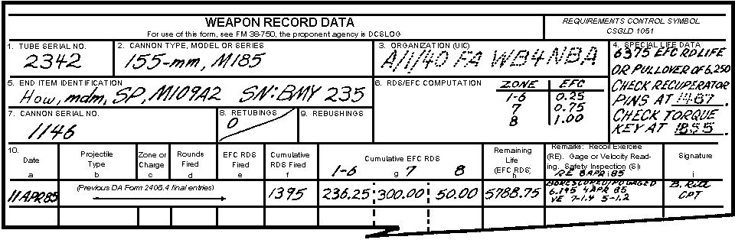

Figure 10. Partially completed DA Form 2408-4.

Now, you will learn how to complete block 10. Correct entries and data computation are essential.

a. Column a. Enter the current calendar date for the action (for example, 12 Apr 85). Never use the Julian date.

PRACTICE EXERCISE:

4. Enter the date (20 Apr 85) in column a of block 10 in Figure 11.

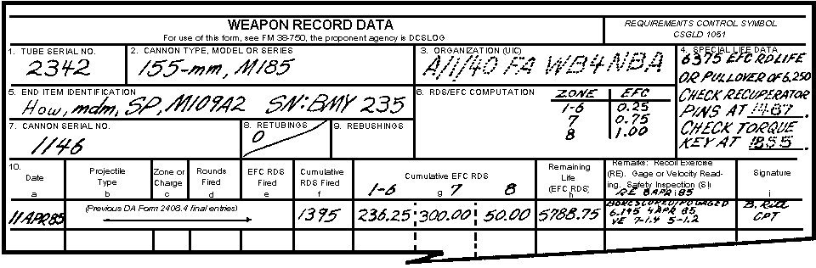

Figure 11. DA Form 2408-4 for Question 4.

////////////////////////////////////////////////////////////////////////////////////////////////////////////////////////////////////////////////////////////////

ANSWER:

4.

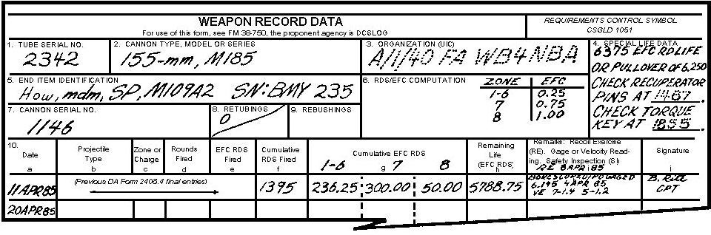

Figure 12. Answer for Question 4.

////////////////////////////////////////////////////////////////////////////////////////////////////////////////////////////////////////////////////////////////

b. Column b. Enter the type of projectile and model number that was fired on the entry date. The model number for the projectile type can be obtained from the technical manual for the howitzer (for example, HE M107, SMK M116, WP M110, ICM 449A1).

PRACTICE EXERCISE:

5. Enter the following data in column b, of block 10 in Figure 13.

- High explosive (HE) M107.
- Improved conventional munition (ICM) M449A1.
- White phosphorous (WP) M110.

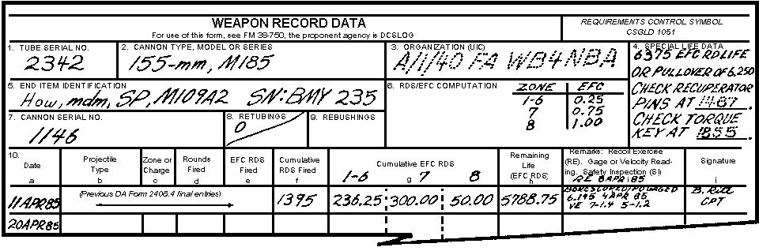

Figure 13. DA Form 2408-4 for Question 5.

////////////////////////////////////////////////////////////////////////////////////////////////////////////////////////////////////////////////////////////////

ANSWER:

5.

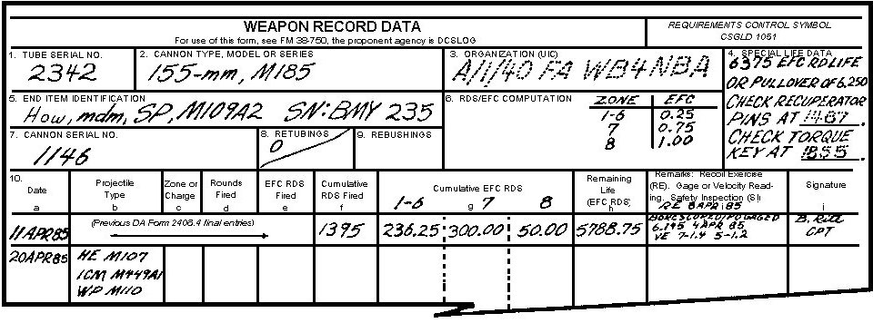

Figure 14. Answer to Question 5.

////////////////////////////////////////////////////////////////////////////////////////////////////////////////////////////////////////////////////////////////

c. Column c. Enter the number of the highest zone fired and the model number of the charge.

5 6 8
EXAMPLE:
M1 M2 M118A1

PRACTICE EXERCISE:

6. Enter the following data in column c, of block 10 in Figure 15.

3 7 8

(HE) M3A1 (ICM) M4A2 (WP) M119A1

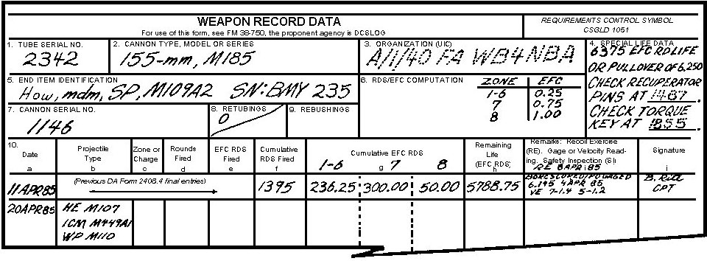

Figure 15. DA Form 2408-4 for Question 6.

////////////////////////////////////////////////////////////////////////////////////////////////////////////////////////////////////////////////////////////////

ANSWER:

6.

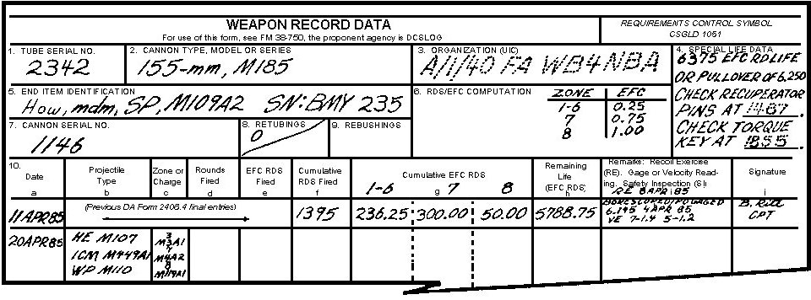

Figure 16. Answer to Question 6.

////////////////////////////////////////////////////////////////////////////////////////////////////////////////////////////////////////////////////////////////

d. Column d. Enter the total number of rounds actually fired for each charge recorded in column c.

PRACTICE EXERCISE:

7. Enter the following data in column d, of block 10 in Figure 17.

40 HE 9 ICM 10 WP

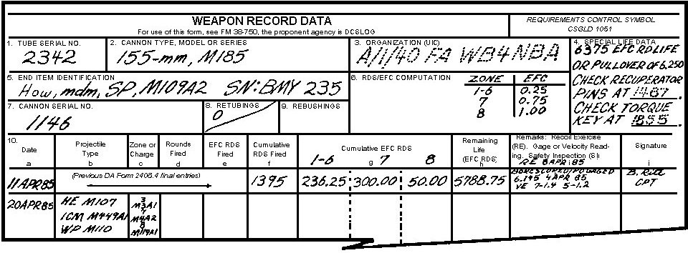

Figure 17. DA Form 2408-A for Question 7.

////////////////////////////////////////////////////////////////////////////////////////////////////////////////////////////////////////////////////////////////

ANSWER:

7.

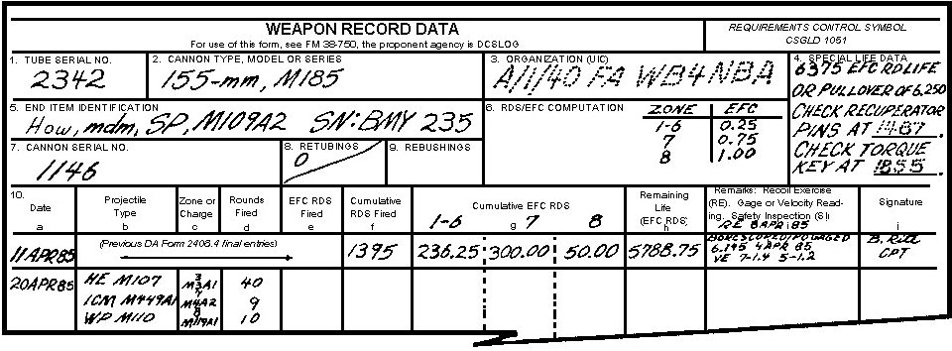

Figure 18. Answer to Question 7.

////////////////////////////////////////////////////////////////////////////////////////////////////////////////////////////////////////////////////////////////

e. Column e. Enter the EFC rounds fired. This is done by multiplying the entry in column d by the EFC factor assigned the charge in block 6. For example, an M109A2 howitzer fired 40 rounds at Charge (chg) 5, 10 rounds at Charge 7, and 12 rounds at Charge 8. You determine the number of EFC rounds fired at each charge as follows:

40 (rounds fired) 10 (rounds fired)
x 0.25 (EFC factor for Chg 5) x 0.75 (EFC factor for Chg 7)
200 50
80 70
10.00 (EFC rounds fired) 7.50 (EFC rounds fired)

12 (rounds fired)
x 1.00 (EFC factor for Chg 8)
12.00 (EFC rounds fired)

PRACTICE EXERCISE:

8. Determine the number of EFC rounds fired by using the information given in column d and below. Complete the entry for column e of block 10 in Figure 19.

40 HE 9 ICM 10 WP

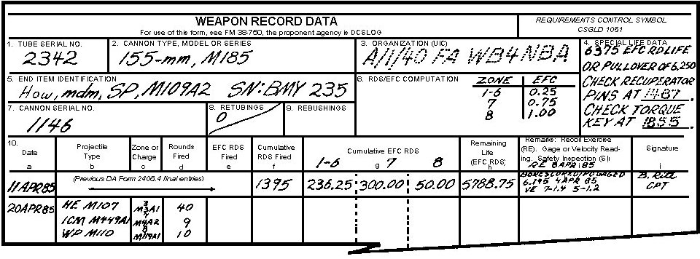

Figure 19. DA Form 2408-4 for Question 8.

////////////////////////////////////////////////////////////////////////////////////////////////////////////////////////////////////////////////////////////////

ANSWER:

8.

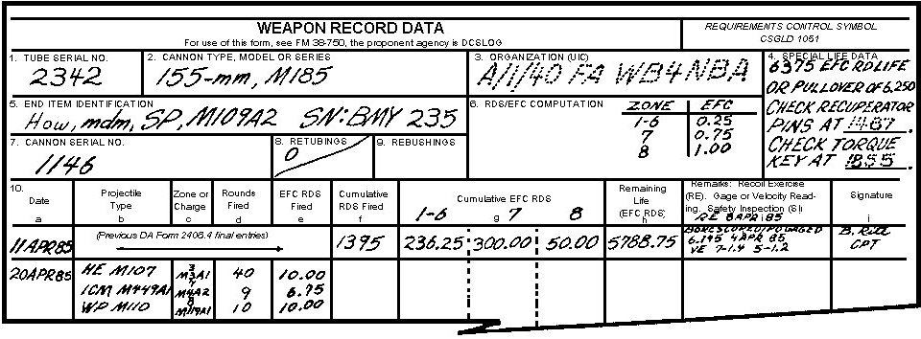

Figure 20. Answer to Question 8.

////////////////////////////////////////////////////////////////////////////////////////////////////////////////////////////////////////////////////////////////

f. Column f. Add the total number of rounds fired in column d to the previous total in column f to obtain the new cumulative total.

PRACTICE EXERCISE:

9. Complete the new entries in column f in Figure 21 by using the totals previously determined from column d and column f.

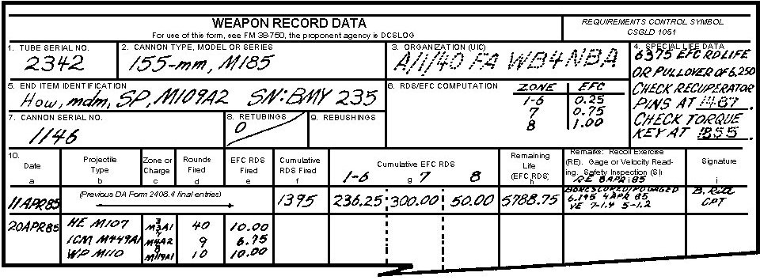

Figure 21. DA Form 2408-4 for Question 9.

////////////////////////////////////////////////////////////////////////////////////////////////////////////////////////////////////////////////////////////////

ANSWER:

9.

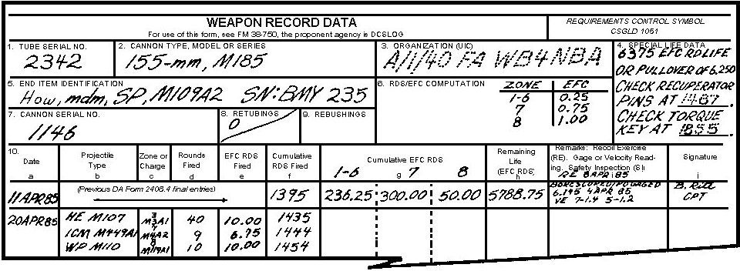

Figure 22. Answer to Question 9.

////////////////////////////////////////////////////////////////////////////////////////////////////////////////////////////////////////////////////////////////

g. Column g. Observe that this column on the form is subdivided. Place the charge figures from block 6 at the top of the appropriate subcolumn. Add the EFC totals from column e to the previous EFC total in column g. The result is the new cumulative total. If your unit has the M198 howitzer, column g must be subdivided into four columns. There are four EFC factors used for the M198 howitzer, so one extra column is required.

PRACTICE EXERCISES:

10. Complete the entry in column g, of block 10 in Figure 23 by using the totals from the data entered previously in column e.

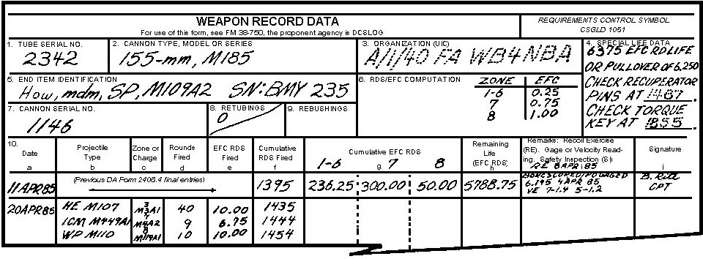

Figure 23. DA Form 2408-4 for Question 10.

////////////////////////////////////////////////////////////////////////////////////////////////////////////////////////////////////////////////////////////////

ANSWER:

10.

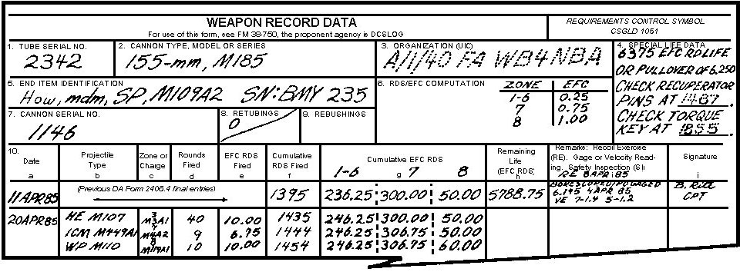

Figure 24. Answer to Question 10.

////////////////////////////////////////////////////////////////////////////////////////////////////////////////////////////////////////////////////////////////

h. Column h. Subtract the EFC rounds fired in column e, from the previous remaining life total in column h. This difference is the new remaining EFC life of the tube.

CAUTION

CARE SHOULD BE TAKEN WHEN CALCULATING THE REMAINING LIFE OF THE CANNON TUBE. ERRORS CAN CREATE A SAFETY HAZARD.

NOTE: A good safety check against making an error is to add the totals in column g to the total in column h. The sum should equal the EFC round life recorded in block 4. If it does not, find the error and correct it. Some howitzer tubes are condemned by using the EFC factor. An error, if not corrected, could be hazardous to your health.

PRACTICE EXERCISE:

11. Complete the entry in column h of block 10 in Figure 25 by using the totals previously entered in column e.

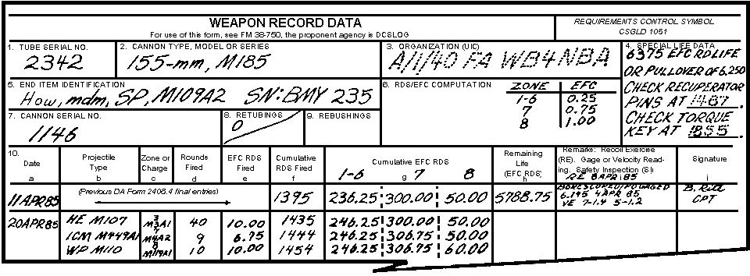

Figure 25. DA Form 2408-4 for Question 11.

////////////////////////////////////////////////////////////////////////////////////////////////////////////////////////////////////////////////////////////////

ANSWER:

11.

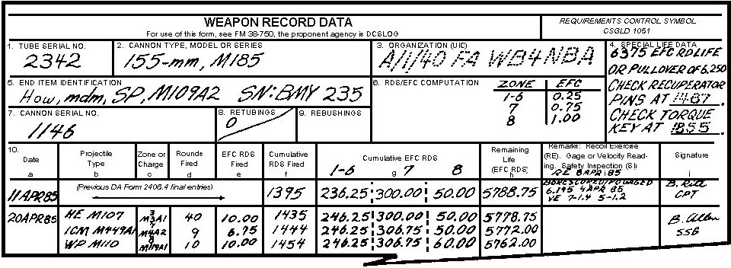

Figure 26. Answers to Question 11.

////////////////////////////////////////////////////////////////////////////////////////////////////////////////////////////////////////////////////////////////

i. Column i. Use column i to record any remarks pertaining to the tube. These may include, but are not limited to, recoil exercise, pullover gage reading, muzzle velocity reading, safety inspection, or borescoping. If a tube has not been borescoped within 90 days of the last firing date, the howitzer is considered unsafe to fire.

j. Column j. Use the signature column for the signature and rank or title of the person making or verifying the entry. If the entry is made by support personnel, the support unit designation will also be entered. The first signature on a new form will be that of the battery commander. He will verify that the correct data was transferred from the previous form. To prevent errors and for ease of reading the form entries, draw a line underneath each entry unless there is more than one entry for a day. Draw a line under the last entry for that day.

6. DISPOSITION OF DA FORM 2408-4. When a new DA Form 2408-4 is prepared, the old form will be forwarded to: Commander, Watervliet Arsenal, ATTN: SMCWV-QAP, Watervliet, NY 12189. Information or requests concerning the use of DA Form 2408-4 or a previous DA Form 2408-4 for a howitzer may be obtained from this address. When requesting previous DA Forms 2408-4 the request should include: tube serial number; cannon size, model or series; and cannon serial number. If none of the above are available, send all known data for the howitzer.

////////////////////////////////////////////////////////////////////////////////////////////////////////////////////////////////////////////////////////////////

SELF-EVALUATION:

You are the chief of section of an M109A2 howitzer. Make the following entries for May 22, 1981, on the DA Form 2408-4 provided. Use the data below.

6,375 EFC or pullover gage of 6.250
Check recuperator pins at 1468
Check torque key at 1725
A/2-50th FA; WA2QAA
23415 (tube)
18911 (cannon)
How mdm, SP, M109A2 (SN: BMY 2345)
155-mm, M185
SSG P. KNOCK
1 (retubing)/1075
Chg EFC
1-6 0.25
7 0.75
8 1.00
3
22 May 1985 HE M107 63 rounds M3A1
6
WP M110A1 5 rounds M4A2
7
SMK M116 2 rounds M4A2

PREVIOUS DATA

a f g h i
11 Apr 85 1395 236.25 300.00 50.00 4413.75 Borescoped PO
gage 6.145 4 Apr 82
VE 7-1.4
VE 5-1.2

j
A. Bone
CPT

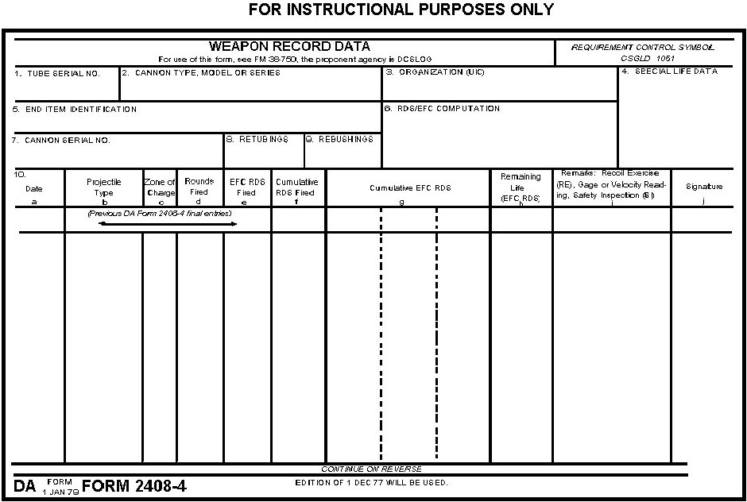

Figure 27. DA Form 2408-4 for self-evaluation.

////////////////////////////////////////////////////////////////////////////////////////////////////////////////////////////////////////////////////////////////

ANSWER:

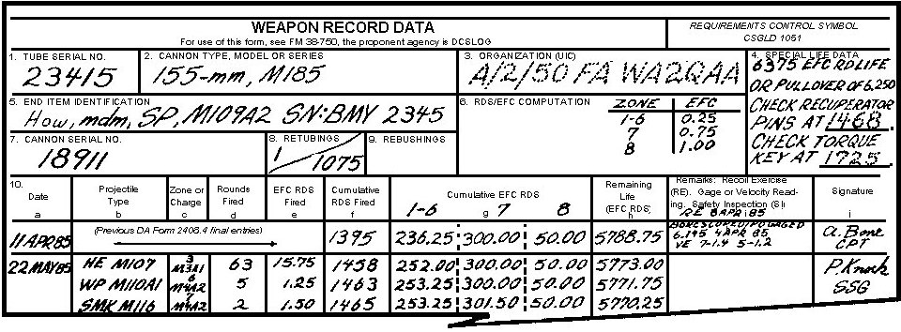

Figure 28. Answer to self-evaluation.

///////////////////////////////////////////////////////////////////////////////////////////////////////////////////////////////////////////////////////////////

NOTE: If you had any problems filling out the form, go back and study the material before taking the examination.

7. SUMMARY. DA Form 2408-4 is a historical record that provides a continuous record of firings and other information related to the length of time that a tube can be used before it needs to be replaced.

a. A tube that has not been borescoped within 90 days after it was last fired is considered unsafe to fire.

b. Correctly computing data and entering it in the proper place on the form reduces the possibility of a tube exploding during firing.

c. DA Form 2408-4 will accompany the howitzer when it is to be fired, repaired, evacuated to support maintenance, or placed in storage.

